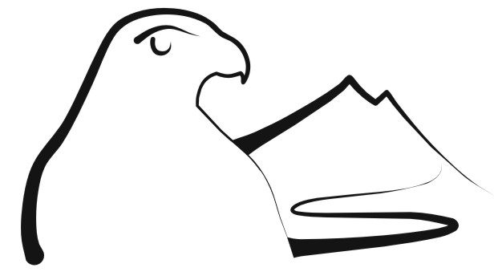 | Information on Observing  New Zealand Falcon

Introduction

The New Zealand falcon (also known as the Sparrow Hawk, Bush Hawk, Karearea) is a medium sized fast flying falcon that is endemic to New Zealand – that is found only in New Zealand. The NZ falcon together with the Morepork and Australasian Harrier are the only three native birds of prey in New Zealand.

Regarded as a very variable species, there are currently three forms of NZ falcon recognized that vary in size, colour and preferred habitat. They are distributed throughout New Zealand, except for Northland and Coromandel, where they are only occasionally observed. The ‘Bush falcon’, the smallest and darkest in colour, is found in the forests of the North Island, the northwestern South Island and the West Coast. The ‘Eastern falcon’ which is largely found in the open country of the eastern South Island, is the lightest in colour but largest in size. Whilst the ‘Southern falcon’ which is found in coastal Fiordland, Stewart and Auckland Islands, is intermediate in both terms of size and colour.

The NZ falcon is often heard before it is seen, as they can be very vocal with a distinctive ‘kek-kek-kek-‘ used as communication, territorial defence and in courtship.

Male vs Female
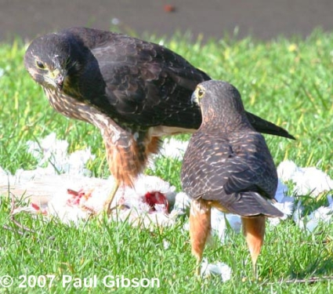

The female NZ falcon is the larger of the two, being two-thirds again the size of the male (hence the name “tercel” being sometimes used to refer to a male falcon).

To the inexperienced eye it can be very difficult to tell them apart, unless seen together. Generally with practice and frequency of close observations distinguishing gender can become easier.

Adult vs Juvenile

Provided a good observation is made it can be relatively easy to tell an adult and a juvenile falcon apart (see below). The adult will have a yellow cere (top of beak), yellow fleshy parts around the eyes and feet, whilst the juvenile’s feet, cere and eyes ring will be a light grey colour. Also the juveniles are more uniformly dark in colour lacking the ‘narrowly barred white’ chest and rufus coloured feathers around the legs.
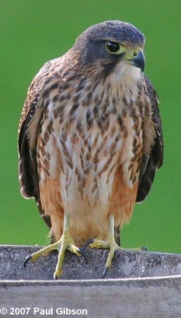
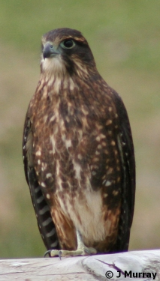

Breeding Falcons

Generally it seems NZ falcon will remain in their home territory all year round. Exact sizes of breeding territories might vary greatly and will be dependent on a number of factors including availability of prey.
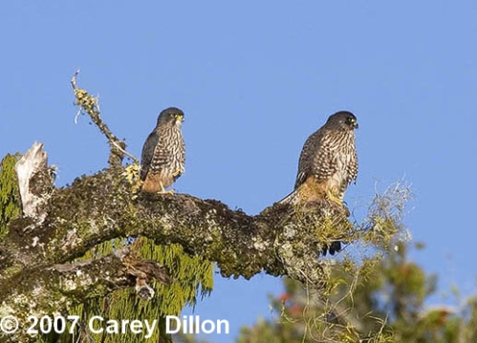
The first signs that a breeding pair may be present is the male circling and “‘kek-king” high above the territory.

Noisy swooping and chasing flights performed by the pair and food transfers are forms of courtship.

Whining ‘whee-up’ calls made by the female are also an excellent indication of breeding activity.

The Nest
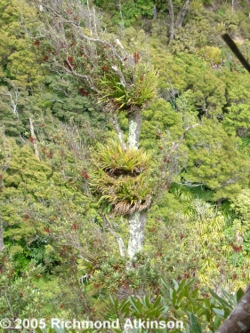

The NZ falcon will either nest on the ground, under the lee of a rocky outcrop or fallen (cut) tree, or in the epiphytic growths of an emergent tree. When nesting on the ground falcons do not construct a nest as such but merely make a scrape in the chosen site.

The same nest site is not always used every year but can be. Often the pair will move to the next gully or another site in the same gully.

The NZ falcon is world renowned for their nest defence and will ‘dive-bomb’ one and all intruders that come to close to the nest.
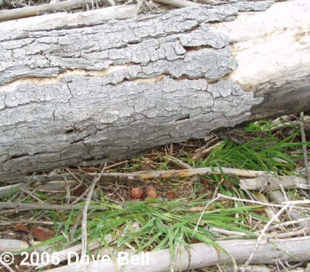

If dive-bombed by a single or pair of falcon it will generally mean you’re within 50-100 m of a nest and should withdraw if possible, to avoid the nest being disturbed or even deserted.

The Eggs
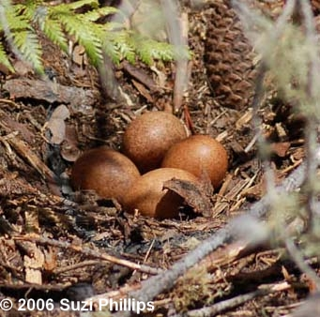

Laying can be from as early as late August to as late as January. Between 1 and 4 may be laid.

The eggs are buff to rich reddish brown with dark chocolate blotches and are 49 x 37 mm in size.

Incubation is mostly carried out by the female and can take approx 30 days during which time the male does most of the hunting and provides food to the female.

NZ Falcon vs Australasian Harrier

The key points to look out for when confirming an identification/sighting of a NZ falcon or differentiating between a falcon and a harrier are;

Key | NZ Falcon | Australasian Harrier
Size | Magpie size  ½ size of a Harrier | Black-backed gull size
Description | Dark and fast  Black/dark brown above – buff barred and streaked below  Rufus/red “pants”  Brown eyes | Generally slow flying – quartering the ground  Juvenile dark brown  Gets paler with age  Yellow eyes & long legs
Flying away | Rump is dark coloured | Cream rump visible
Flight Characteristics | Flies fast – rapid wing beat | Slow flight often flap-glide-flap
Soaring | Wings flat for short time | Wings held in shallow ‘V’ for lengthy periods
Hunting | Very fast – stoops  Chases smaller birds | Searches slowly into wind  Quarters open country  Drops on prey
Typical Prey | Small birds  Rarely eat carrion | Mammals  Eats carrion
Call | Rapid, piercing  Kek-Kek-Kek | Generally silent  Plaintive Kee-a
Flight Silhouette
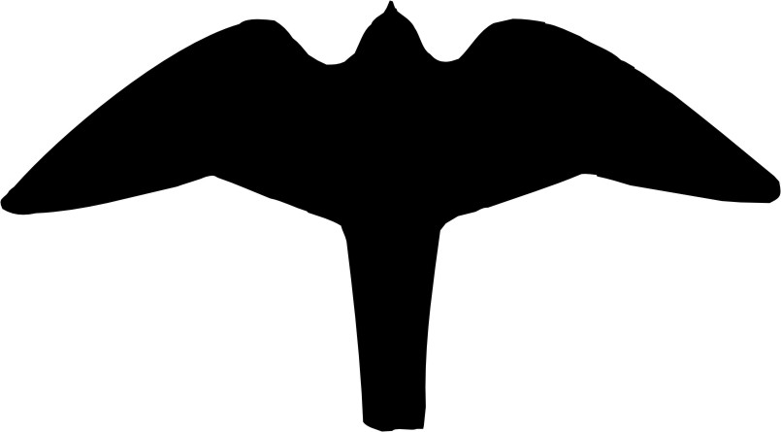
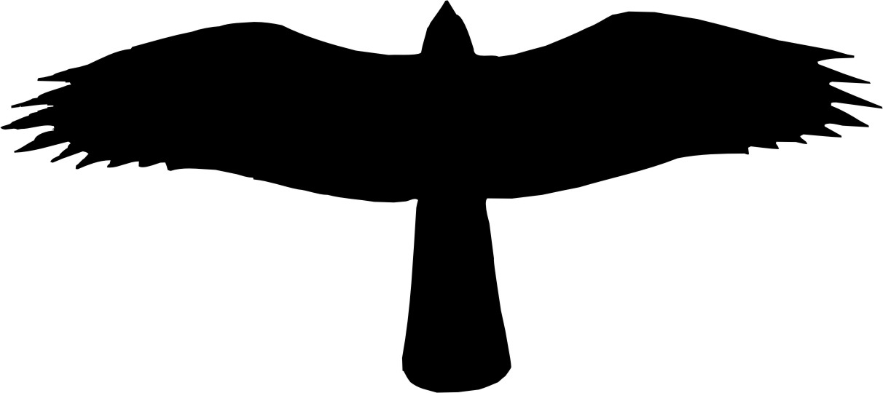

Time of the Year

Often the time of year will assist with the confirmation of NZ falcon activity;

- Spring – Courtship and territorial activity by breeding pairs.
- Summer – Breeding, nest defence and male food passing to female/fledglings.
c. Autumn – Juveniles more often seen as they disperse from home territory.
d. Winter – Generally less observations made.

Acknowledgements

Native Birds Taranaki wishes to acknowledge the kind permission granted by the photographers for the use of their images in this guide.

